**PRACTICAL-9**

**AIM**

Create a remote connection using open SSH

**IMPLEMENTATION**

* Firstly, check for the services available.

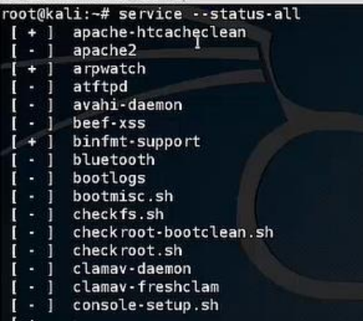

* Then, install openssh-server

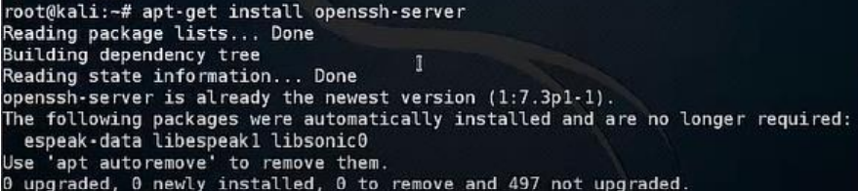

* Start the ssh service and server



* Check for the service status

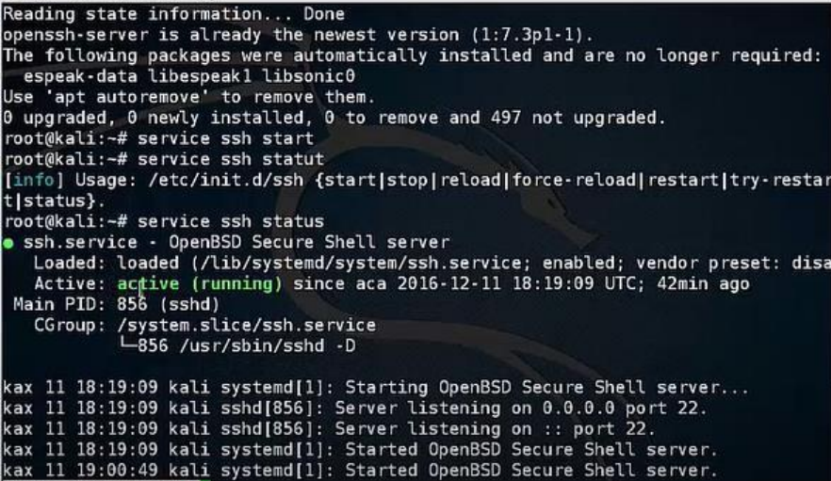

* Navigate to ssh folder to check the details of the connection

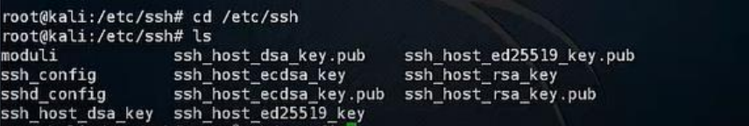

**CONCLUSION**

In this practical, we learnt to establish remote openssh connection.